SALIPUR AUTONOMOUS COLLEGE,SALIPUR
INTERNAL QUALITY ASSURANCE CELL
Proceedings of
NALCO Sponsored State level Seminar organized on
30th October 2019
- Theme of the Seminar:

“QUALITY ASSURANCE IN HIGHER EDUCATION INSTITUTIONS (HEIs)”
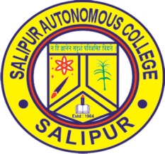
- The Programme Schedule
PROGRAMME SCHEDULE
30th Nov33

09.30 a.m – 10.15 a.m : Registration
10.30 a.m – 11.50 a.m : Inaugural Function
Chief Guest: Dr. Sasmita Samant
Pro-Vice Chancellor,KIIT & KISS University
11.50 am – 12.05 p.m : Tea break

12.05 p.m – 1.10 p.m : Technical Session I
Topic : Preparation of IIQA.
Resource Person : Dr. Jayanta Parida
Co-ordinator, QAC, KIIT & KISS
Former Director,Academic Staff College,
1.10 p.m – 2.15 p.m : Technical Session II
Topic: Quality and Accreditation of Higher Education Institutions (HEIs)
Resource Person : Dr.Ranjan Kumar Bal
Former Chairman P.G.Council,
Professor of Commerce
& Co-ordinator, IQAC
Utkal University,Bhubaneswar
02.15 p.m – 3.00 p.m : LUNCH BREAK
03.00 p.m – 4.00 p.m : Interactive & Valedictory Session

Report of the One day NALCO Sponsored State level Seminar on “Quality Assurance in Higher Education Institutions”

Organized on 30th October 2019
One day State Level Seminar Sponsored by NALCO on
“Quality Assurance in Higher Education Institutions” was organized by the Internal Quality Assurance Cell (IQAC) of Salipur Autonomous College, Salipur on 30th October 2019. Hundred participants from Thirty colleges including the Principals of 15 colleges and faculty members of Salipur Autonomous College(SAC) attended the Seminar. Dr. Basanta Kumar Rout, Principal, Salipur Autonomous College presided over the inaugural ceremony of the State Level Seminar.Dr. U.C.Pati,Vice-Principal & Prof. in charge UGC welcomed the gathering. Dr. D.N.Patri, Co-ordinator, IQAC of SAC presented the Theme of the Seminar., Dr. Sasmita Samant, ProVice-Chancellor, KIIT & KISS University and the Chief Guest of this occasion addressed in the inaugural ceremony of the National Seminar. She highlighted on ‘Quality Aspiration and designing disruptions in Higher Education’ and stressed on Revisiting the Organisational Vision and Mission, Redefining organizational objectives, Redefining Learning Outcomes, Focus on inculcating Continuous Learning culture, Blended Learning, Refinement of evaluation System. Dr Asit Parija, Associate Prof. I/C UGC proposed a Vote of Thanks.

In the First Technical Session, Prof. (Dr) Jayanta Ku. Parida,Co-ordinator QAC, KIIT University, Bhubaneswar, spoke on “Preparation of IIQA & SSR”. The Resource Person insisted on the benefits of accreditation and the systematic process to sustain quality and how benchmarking should be integrated into the fundamental operations of the Institutions. He enumerated how to sustain quality in all the seven criteria. He enumerated the check list to be kept while SSR preparation and submission.
In the Second Technical Session, Prof( Dr) Ranjan Kumar Bal, Former Chairman P.G.Council & Professor of Commerce & Co-ordinator, IQAC,Utkal University,Bhubaneswar delivered a lecture on “QUALITY AND ACCREDITATION OF HIGHER EDUCATION INSTITUTIONS (HEIs)”.He stated that IQAC is a Gift of NAAC – Quality Culture – Nodal -Agency – TEAM, He also focused on 7 Criteria – 34/32 Key Indicators – 137/136/121. He spoke on the need for innovation in curriculum design and listed the open educational e-resources which will enhance ICT learning process. He explained Methodological Innovation, Technological Innovation and insisted that mixed Methodology need to be adopted in Social Sciences.

In the Valedictory function Chaired by Dr. Basanta Ku. Rout, Principal, SAC- Professor Sasmita Samant, Professor Ranjan Ku. Bal, and Professor Jayanta Ku Parida interacted with Principals and co-ordinators of IQAC of 15 colleges. Dr. A.Parija Professor I/C UGC offered the vote of thanks. All the teaching and non-teaching staff with the IQAC members made all the arrangements for the successful conduct of the seminar.
FEEDBACK

The participants gave a positive feedback that the Seminar enabled them to understand Revised Assessment and Accreditation Framework of NAAC in a lucid manner.

MEMORIES:

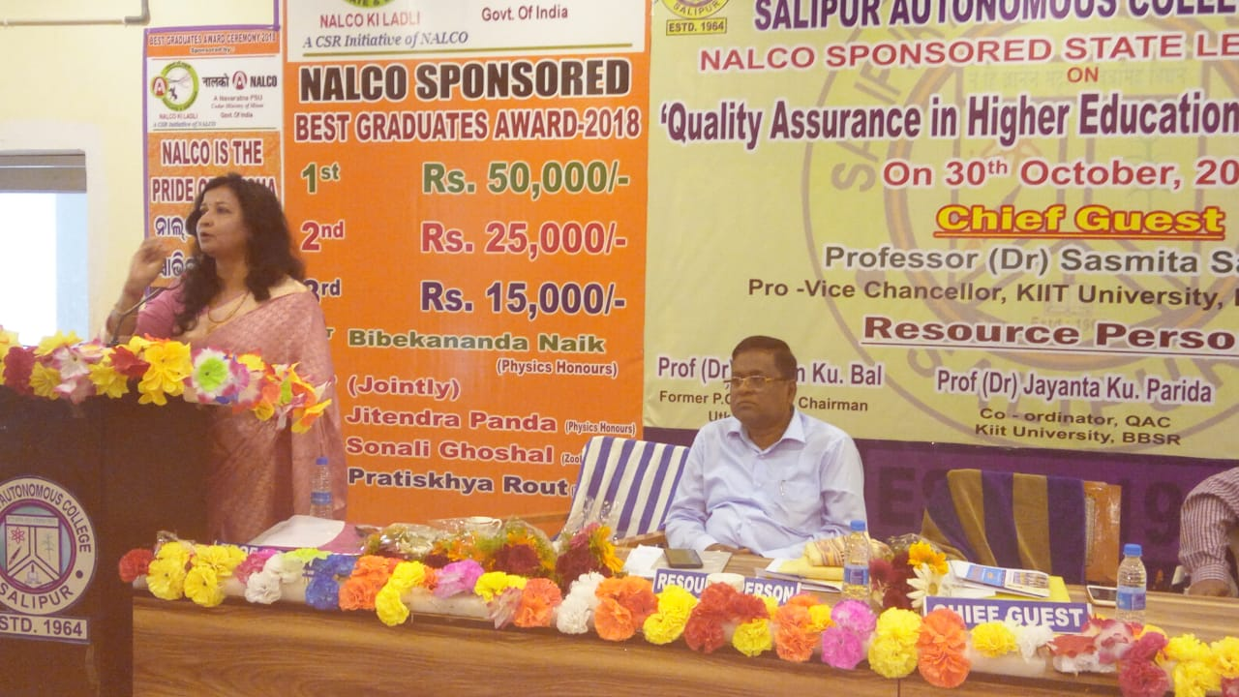
Inaugural Ceremony: Chief Guest Dr. Sasmita R. Samant, Pro-Vice Chancellor, KIIT University, on ‘Quality Aspiration and designing disruptions in Higher Education’

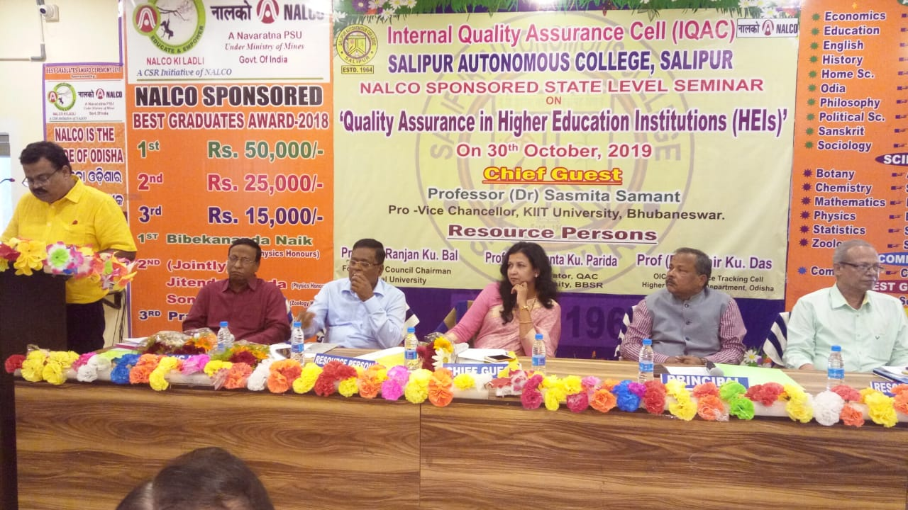

Inaugural Ceremony – Organizing Secretary Dr D.N.Patri, Co-ordinator, IQAC,
Salipur Autonomous College presenting the Theme of the Seminar.

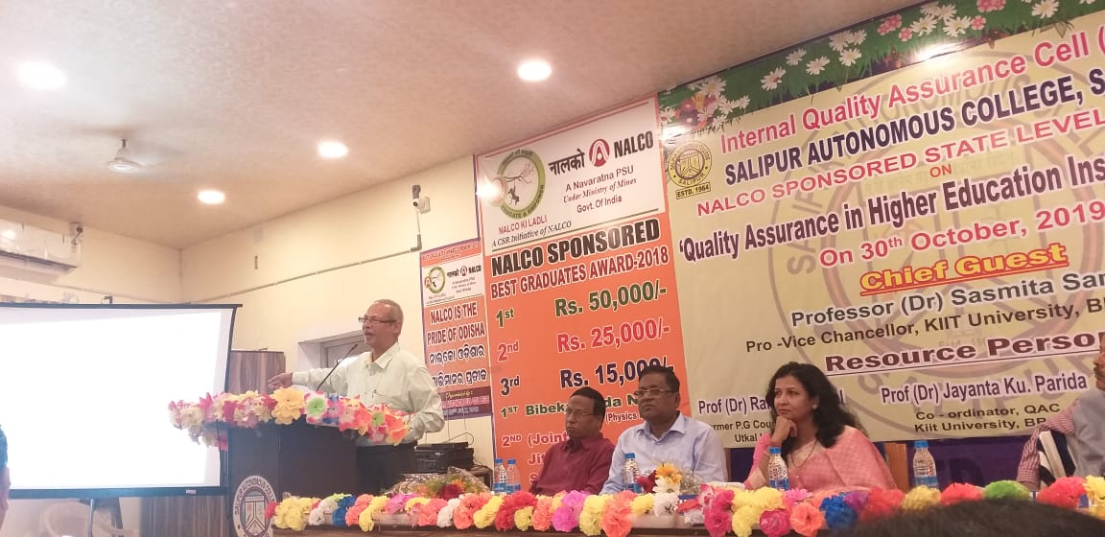
TECNICAL SESSION-II : Resource Person Professor Ranjan Kumar Bal on ‘QUALITY AND ACCREDITATION
OF HIGHER EDUCATION INSTITUTIONS (HEIs)’
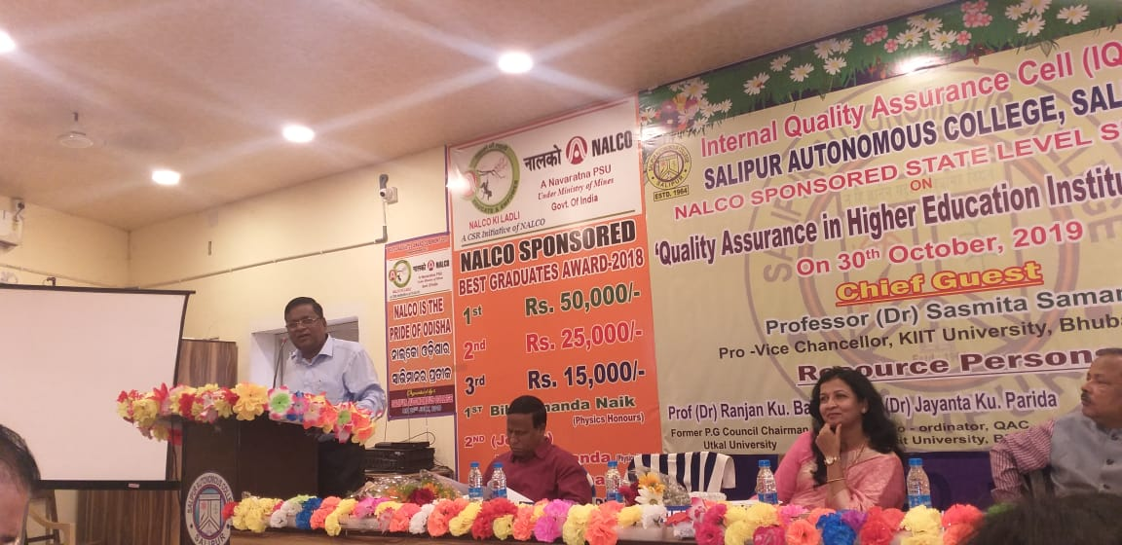

TECNICAL SESSION-I: Resource Person Professor Jayanta Ku. Parida on
‘Preparation of IIQR & SSR’

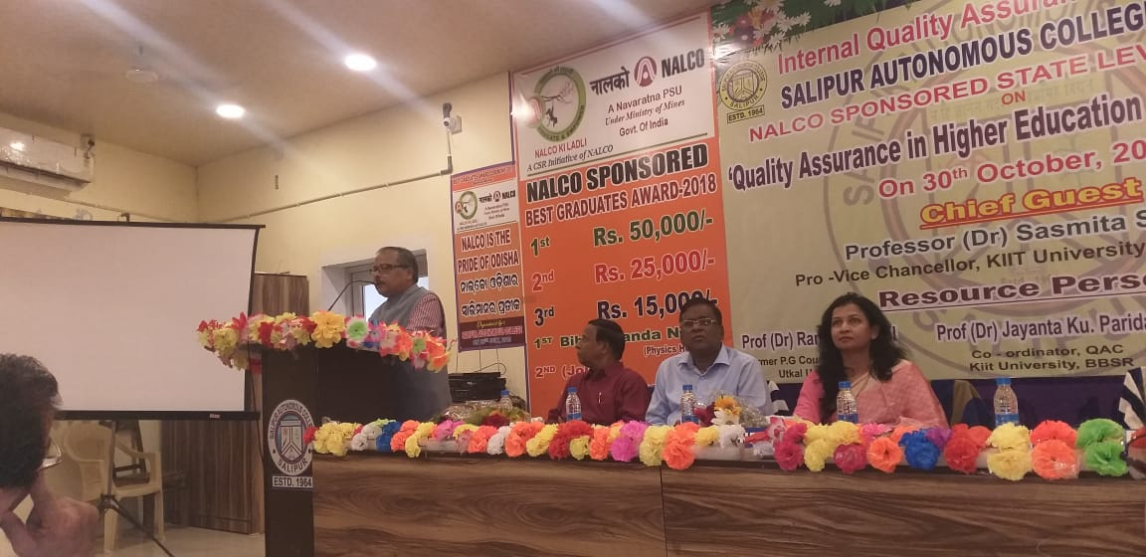

PRESIDENTIAL ADDRESS: Chairman of the Seminar Dr. Basanta Kumar Rout, Principal, SAC

in the inaugural ceremony.

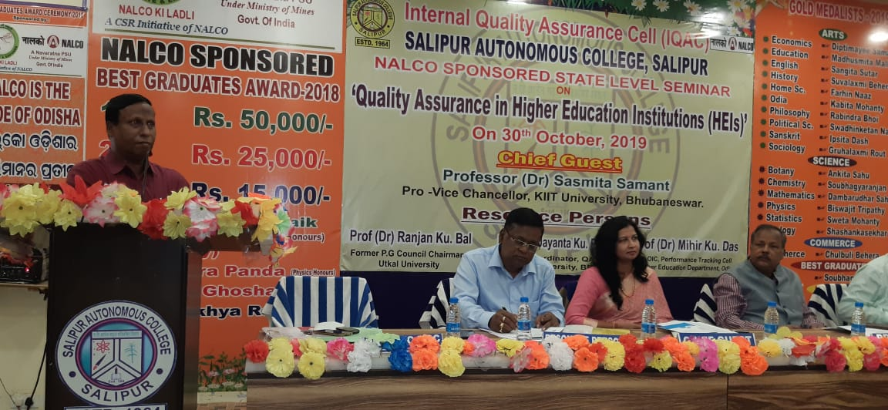

WELCOME ADDRESS: Convenor of the Seminar Dr.Umesh Chandra Pati, Vice Principal &

Professor I/C UGC, SAC in the inaugural ceremony.

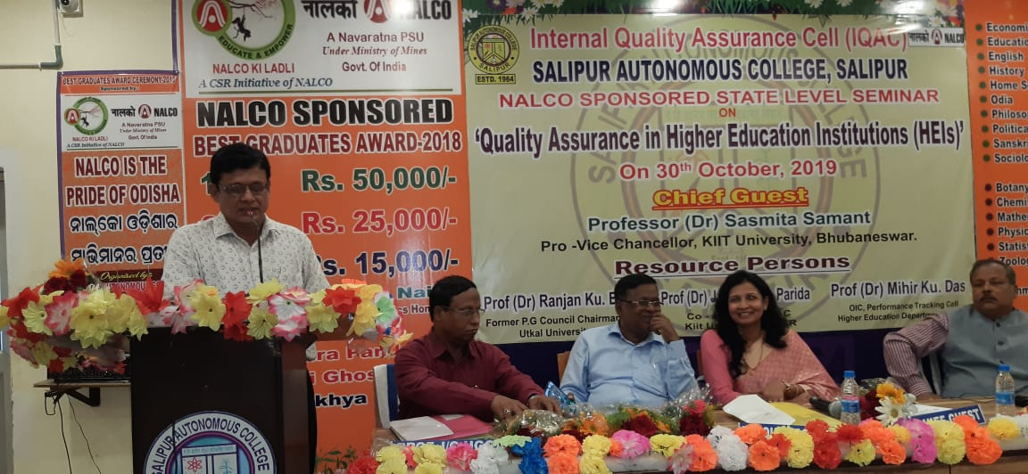
VOTE OF THANKS: Dr. Asit Parija, Associate Prof. I/C UGC offering vote of thanks
in the Inaugural Ceremony.

